**Lab # 03**

**SRS (Software Requirement Specification)**

his is an example of a [**business use case**](http://www.uml-diagrams.org/use-case.html#business-use-case) diagram which is usually created during **Business Modeling** and is rendered here in **Rational Unified Process**(RUP) notation.

[**Business actors**](http://www.uml-diagrams.org/use-case-actor.html#business-actor) are Passenger, Tour Guide, Minor (Child), Passenger with Special Needs (e.g. with disabilities), all playing **external roles** in relation to airport business.

[**Business use cases**](http://www.uml-diagrams.org/use-case.html#business-use-case) are Individual Check-In, Group Check-In (for groups of tourists), Security Screening, etc. - representing business functions or processes taking place in airport and serving the needs of passengers.

Business use cases Baggage Check-in and Baggage Handling extend Check-In use cases, because passenger might have no luggage, so baggage check-in and handling are optional.

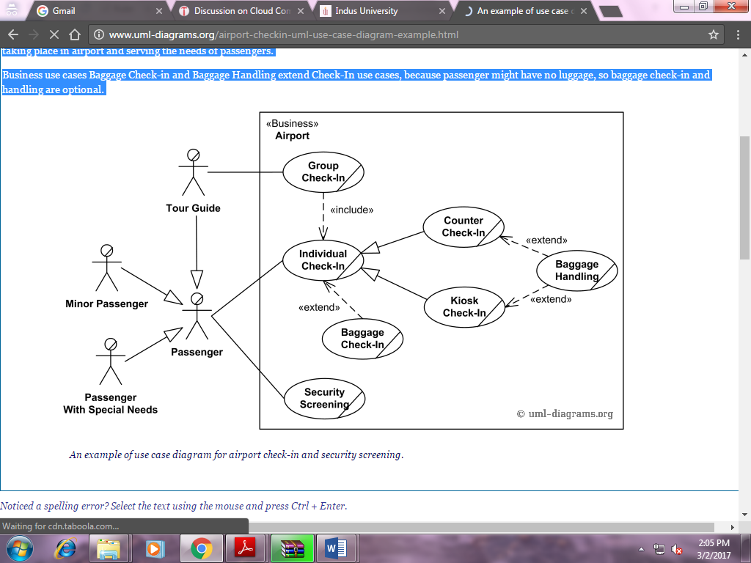

**Online Library Public Access Catalog**

***UML Use Case Diagram Examples***

An **Online Public Access Catalog** (**OPAC**) is an e-Library website which is part of **Integrated Library System** (ILS), also known as a **Library Management System** (LMS), and managed by a library or group of libraries.

Patrons of the library can search library catalog online to locate various resources - books, periodicals, audio and visual materials, or other items under control of the library. Patrons may reserve or renew item, provide feedback, and manage their account.

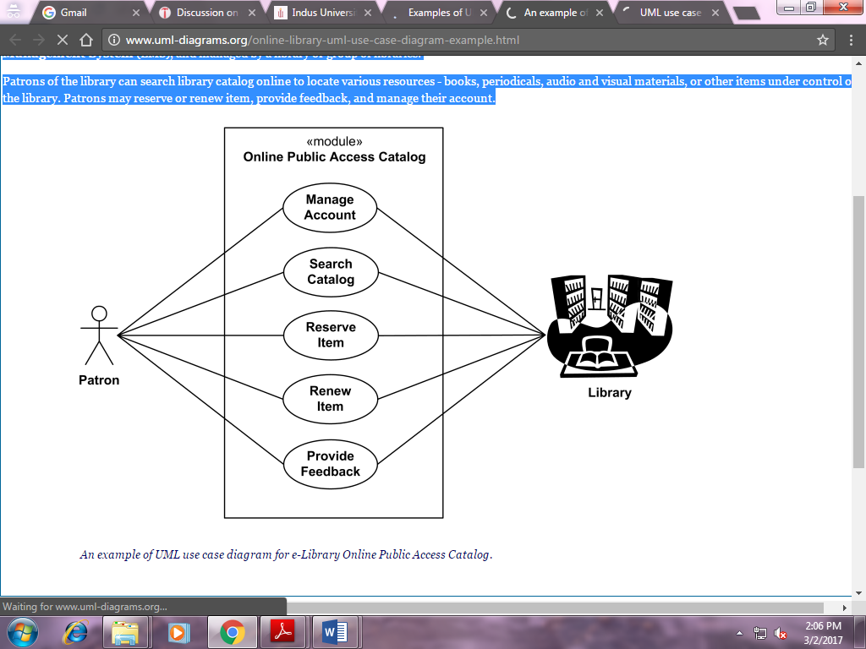

# Online Shopping

## *UML Use Case Diagram Example*

**Web Customer** [**actor**](http://www.uml-diagrams.org/use-case-actor.html) uses some web site to make purchases online. Top level [**use cases**](http://www.uml-diagrams.org/use-case.html) are **View Items**, **Make Purchase** and **Client Register**. View Items use case could be used by customer as top level use case if customer only wants to find and see some products. This use case could also be used as a part of Make Purchase use case. Client Register use case allows customer to register on the web site, for example to get some coupons or be invited to private sales. Note, that **Checkout** use case is [**included use case**](http://www.uml-diagrams.org/use-case-include.html) not available by itself - checkout is part of making purchase.

Except for the **Web Customer** actor there are several other actors which will be described below with detailed use cases.

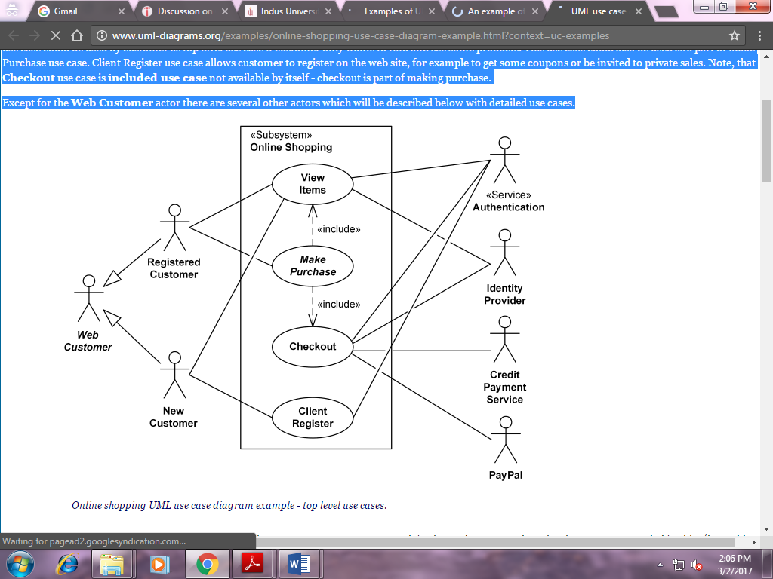

**View Items** use case is [**extended**](http://www.uml-diagrams.org/use-case-extend.html) by several optional use cases - customer may search for items, browse catalog, view items recommended for him/her, add items to shopping cart or wish list. All these use cases are extending use cases because they provide some optional functions allowing customer to find item.

**Customer Authentication** use case is [**included**](http://www.uml-diagrams.org/use-case-include.html) in **View Recommended Items** and **Add to Wish List** because both require the customer to be authenticated. At the same time, item could be added to the shopping cart without user authentication.

